Clocks SFML – Tutorial 02

Specification
- ASSESSED Using your new Time class, create a graphical SFML application to help children learn to tell the time. The ‘game’ is only a prototype. Show analogue clock faces and a digital clock readout, children are then asked questions to test their ability to tell the time.
- Spec: show digital clock reading current time, this clock is updating in real time. Show multiple analogue clock versions, some are wrong, all updating in real time. The player must pick the one correct match. For example:
  - Display question: “Which clock matches the top time? 1 or 2 or 3”
  - Player presses a number key
  - If wrong display: “wrong, try again? <y or n>”
  - If correct display: “correct, try again? <y or n> ”
  - The player can keep going indefinitely
- Produce all the usual design docs: GDD + TDD + Test plan
- Get the usual feedback and record
- There are some sprite sheets you can use or find your own
Competencies: 1.1->1.6,1.8.4,1.8.7,1.8.8,1.9,1.10.2,2.1,2.4.1,2.4.3,2.6.2,2.8.3,2.10.1

Game Design
Overview
The game shows three analogue clocks and a digital clock. The digital clock and one of the analogue clocks are the same. The player must choose which one is correct.
Rules
The player presses either 1,2, or 3 to choose which analogue clock they believe matches the digital clock
Gameplay
The analogue clocks show different times and one matches the digital clock
The player must select a clock that they believe is correct by pressing the corresponding number key (1,2 or 3)
If the player it right, it will say “correct, try again? <y or n>”
If the player is wrong, it will say “wrong, try again? <y or n>”
If the player presses y the game restarts

Technical Design
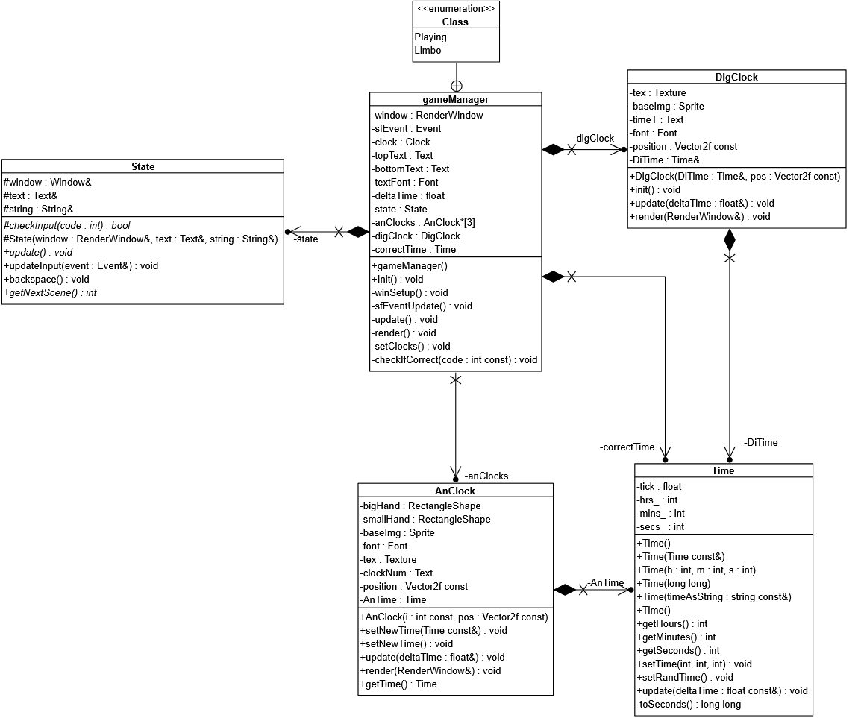
Time.cpp
Time::Time()
Call method setRandTime

Time::getHours()
Return hours

Time::getMinutes()
Return minutes

Time::getSeconds()
Return seconds

Time::setTime(int h, int m, int s)
Set hours to h
Set minutes to m
Set seconds to s

Time::setRandTime()
s = rand() % 86400 + 1
Set hours to s covnerted to hours
Set minues to s converted to minutes
Set seconds to 0

Time::toSeconds()
Return with ( hours converterd to seconds )

Time::update(const float& deltaTime)
Tick += deltaTime
If tick is greater than or equal to 1
seconds += 1
If seconds is greater than or equal to 60
Set seconds to 0
minutes += 1
If minutes is greater than or equal to 60
Set minutes to 0
hours += 1
If hours is greater than or equal to 24
Set hours to 0
EndIf
EndIf
EndIf
Set tick to 0
EndIf

AnClock.cpp
AnClock::AnClock(const int i, const sf::Vector2f pos) : position(pos)
If (cannot load font "Retro.ttf")
Call method throw with "cannot find digital clock text file"
EndIf
Call method clockNum.setString with std
If (cannot load texture "clock_face.png")
Call method throw with "Error loading digital clock texture!"
EndIf
Call method baseImg.setTexture with texture
Call method baseImg.setPosition with sf, position.y plus baseImg.getGlobalBounds
Call method baseImg.setScale with 0.5, 0.5
Call method clockNum.setFont with font
Call method clockNum.setPosition with baseImg.getPosition
Call method clockNum.setLetterSpacing with 1
Call method clockNum.setScale with 1, 1
secondsHand.setFillColor(red)
Call method smallHand.setFillColor with sf
Call method smallHand.setSize with sf, 55
Call method smallHand.setOrigin with sf, smallHand.getOrigin
Call method smallHand.setPosition with sf, baseImg.getPosition
Call method smallHand.setScale with 1, 1
Call method smallHand.setRotation with 180
Call method bigHand.setFillColor with sf
Call method bigHand.setSize with sf, 95
Call method bigHand.setOrigin with sf, bigHand.getOrigin
Call method bigHand.setPosition with sf, baseImg.getPosition
Call method bigHand.setScale with 1, 1
Call method bigHand.setRotation with 180

AnClock::setNewTime(const Time & time)
Set AnTime to time

AnClock::setNewTime()
Call method AnTime.setRandTime

AnClock::getTime()
Return AnTime

AnClock::update(float& deltaTime)
Initialise hour to AnTime.getHours
If hour is greater than or equal to 12
Set hour to hour minus 12
EndIf
Set hour to hour plus ( AnTime.getMinutes divided by 60. ) f
Call method AnTime.update with deltaTime
Call method bigHand.setRotation with ( float )
Call method smallHand.setRotation with ( float )

AnClock::render(sf::RenderWindow & window)
Call method window.draw with clockNum
Call method window.draw with baseImg
Call method window.draw with bigHand
Call method window.draw with smallHand
window.draw(secondsHand)

DigClock.cpp
DigClock::init()
If (cannot load font "digital-7.ttf")
Call method throw with "cannot find digital clock text file"
EndIf
If (if cannot load texture “digital_clock.png")
Call method throw with "Error loading digital clock texture!"
EndIf
Call method baseImg.setTexture with texture
Call method baseImg.setPosition with sf, position.y plus baseImg.getGlobalBounds
Call method baseImg.setScale with .5, .5
Call method timeT.setFont with font
Call method timeT.setPosition with baseImg.getPosition, baseImg.getPosition
Call method timeT.setLetterSpacing with 1
Call method timeT.setScale with 2, 2

DigClock::update(float& deltaTime)
conv time to string
Std::ostringstream os
Const char prev(os.fill('0'))
Os << std::setw(2) << std::to_string(DiTime.getHours()) << ':'
Call method os.fill with prev
Call method timeT.setString with os.str

DigClock::render(sf::RenderWindow & window)
Call method window.draw with baseImg
Call method window.draw with timeT

gameManager.cpp
gameManager::gameManager() : digClock(correctTime, sf::Vector2f(300, 0))
Call method srand with ( unsigned )
game setup
Setup text
Call method throw with "cannot find digital clock text file"
EndIf
Call method topText.setFont with textFont
Call method bottomText.setFont with textFont
Call method topText.setString with "Time to play?"
Call method bottomText.setPosition with 200, 800
setup analogue clocks
Set CLOCK2 of anClocks to new AnClock with CLOCK2, sf, 200
Set CLOCK3 of anClocks to new AnClock with CLOCK3, sf, 200
setup digital clock
Call method setClocks
gameManager::Init()
While (window.isOpen())
Set deltaTime to clock.restart
Call method update
Call method render
EndWhile

gameManager::winSetup()
Call method window.create with sf, 1080, "What's the time?"

gameManager::sfEventUpdate()
If (window.pollEvent(sfEvent))
If ((sfEvent.type == sf::Event::KeyPressed && sfEvent.key.code == sf::Keyboard::Escape) || (sfEvent.type == sf::Event::Closed))
Call method window.close
EndIf
If ((state == State::Playing) && (sfEvent.type == sf::Event::KeyPressed) && ((sfEvent.key.code == sf::Keyboard::Num1) || (sfEvent.key.code == sf::Keyboard::Num2) || (sfEvent.key.code == sf::Keyboard::Num3)))
Call method checkIfCorrect with sfEvent.key.code
EndIf
If ((state == State::Limbo) && (sfEvent.type == sf::Event::KeyPressed) && (sfEvent.key.code == sf::Keyboard::Y))
Call method setClocks
Set state to State
EndIf
If ((state == State::Limbo) && (sfEvent.type == sf::Event::KeyPressed) && (sfEvent.key.code == sf::Keyboard::N))
Call method window.close
EndIf
EndIf

gameManager::update()
Call method sfEventUpdate
Call method digClock.update with deltaTime
For i is 0, i is less than Max_Clock, i increments by 1
update i of anClocks
EndFor

gameManager::render()
Call method window.clear
For i is 0, i is less than Max_Clock, i increments by 1
render i of anClocks
EndFor
Call method window.draw with topText
Call method window.draw with bottomText
Call method window.display

gameManager::setClocks()
Call method bottomText.setString with "Which clock shows the same time as the digital one? 1, 2, or 3"
Call method correctTime.setRandTime
set new time for 0 of anclocks to correctTime
set new time for 1 of anclocks to random time
set new time for 2 of anclocks to random time

gameManager::checkIfCorrect(const int code)
SelectedClock clockNum
Switch on code
Case 27
Set clockNum to CLOCK1
End of Case
Case 28
Set clockNum to CLOCK2
End of Case
Case 29
Set clockNum to CLOCK3
End of Case
Default
End of Case
EndSwitch
Set state to State
If (player choice correct)
Call method bottomText.setString with "correct, try again? "
Else
Call method bottomText.setString with "wrong, try again? "
EndIf

main.cpp
main()
GameManager gm
Call method gm.Init
Return with 0

Test Plan
Expected | Actual
The player presses 1 to choose clock 1 | OK
The player presses 2 to choose clock 2 | OK
The player presses 3 to choose clock 3 | OK
The player presses esc to exit | OK
The player presses y to try another time | OK
The player presses n to exit | OK

Git commit log
